如何设置ping检查的HA
- 在接口上启用ping
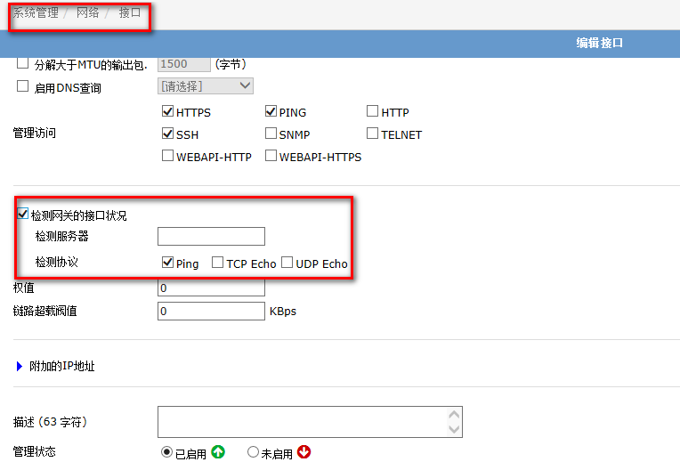
define system interface
edit "port1"
set vdom "root"
set gwdetect enable
set detectserver "192.168.118.182"
set ha-priority 5
next

- 在HA配置中启用ping
define system ha
set pingserver-monitor-interface "port1"
set pingserver-failover-threshold 2 ;ha-priority的累加超过该值时进行切换（0-50）
set pingserver-flip-timeout 6 ;防止出现来回浮动切换的时间值（分钟）（6-2147483647）
end
3、相关参数
define system global
set failtime 1 ;连续ping失败的次数,缺省5次
set interval 1 ;发ping网关时间间隔,缺省5秒
end

测试注意事项：每次切换应等待6分钟以上

