与Openswan建立IPSec VPN

组网需求
通过IPsec VPN（接口模式）将2个局域网连接起来，实现11.1.0.0/16与12.2.0.0/16两个网段的通信。

网络拓扑
PC1-----(port5:192.168.22.254/24)NGFW(port1:192.168.12.98)---Internet-------(ens192.168.22.23)SPENSWAN(ens256:12.2.1.1/24)----PC2

配置步骤
- 防火墙配置：配置接口
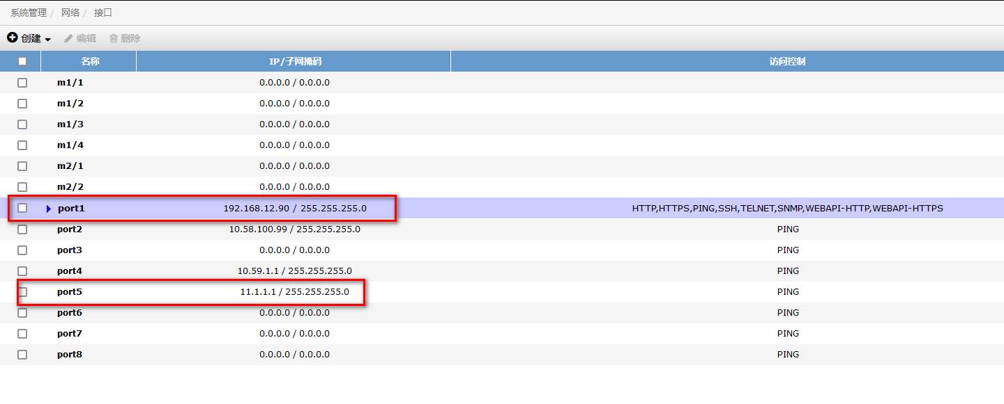

配置IPSEC阶段1
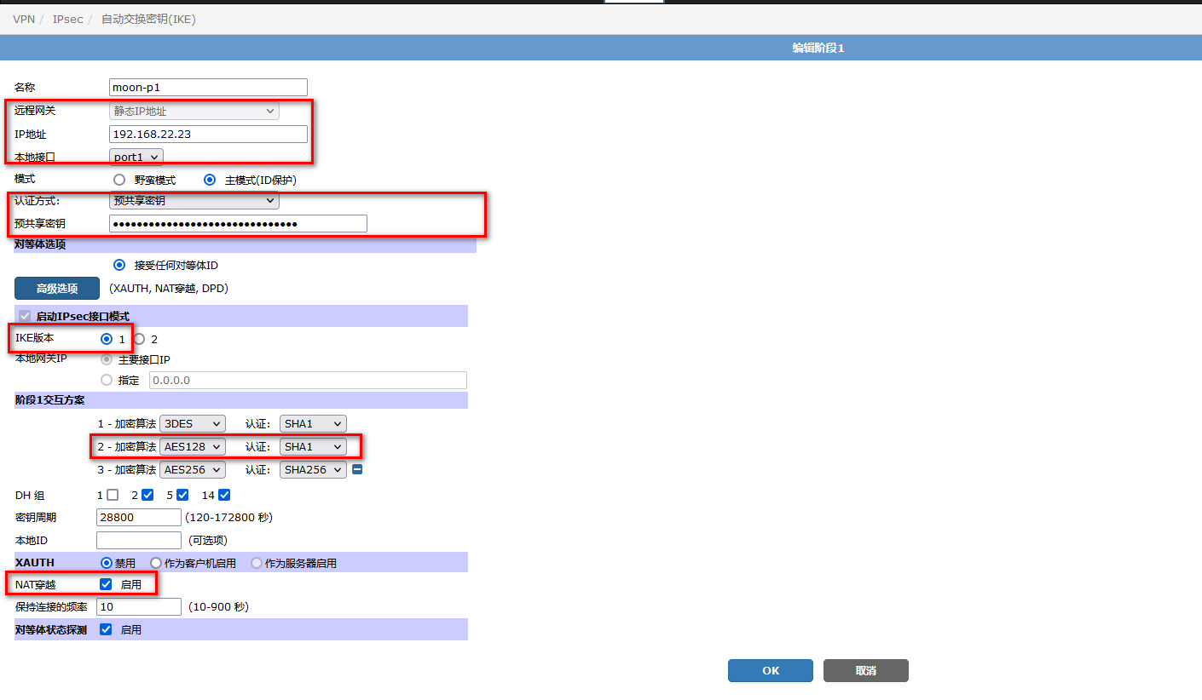

配置IPSec阶段2：
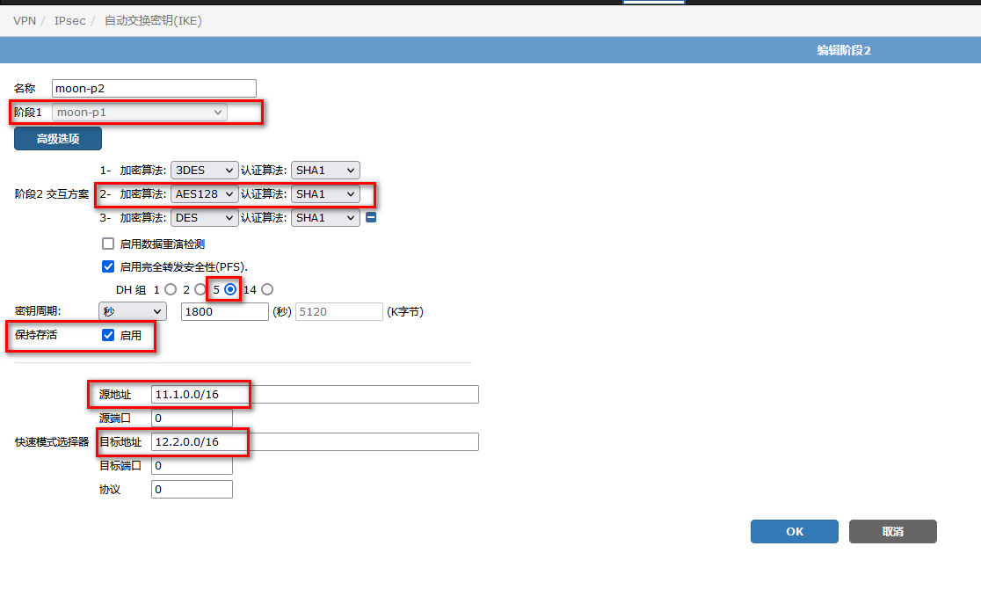

配置策略：
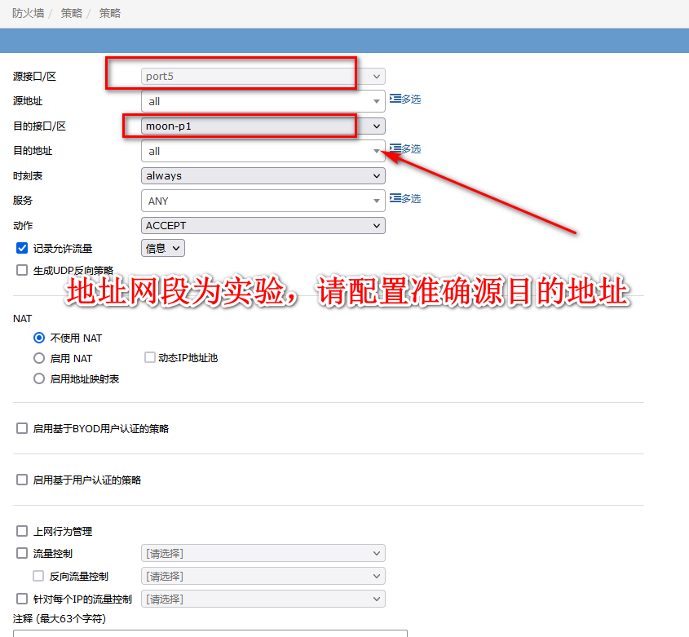

配置路由：
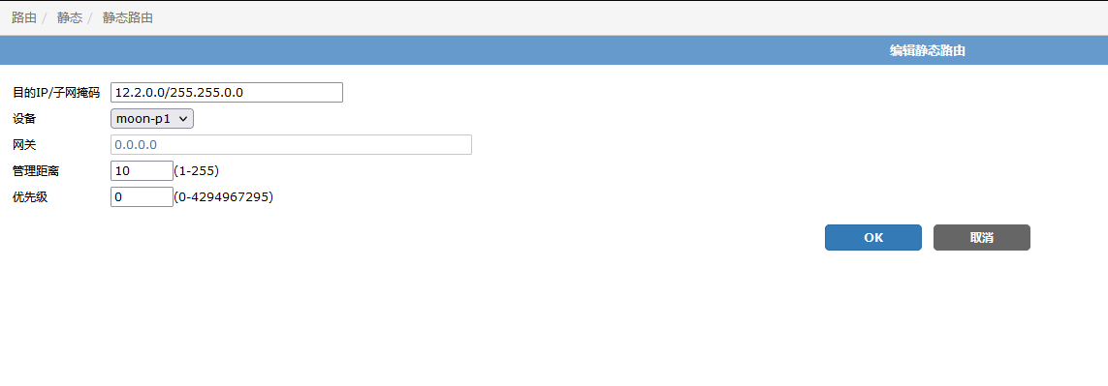
注意：此路由是去程路由，结合实际情况添加其他需要路由

查看：IPSE配置

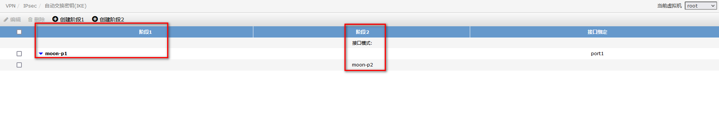

查看Ipsec状态：
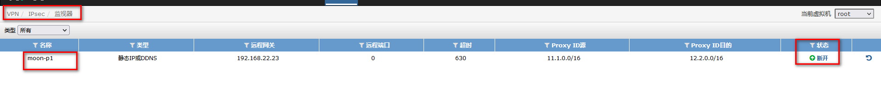
查看IPSEC 日志：
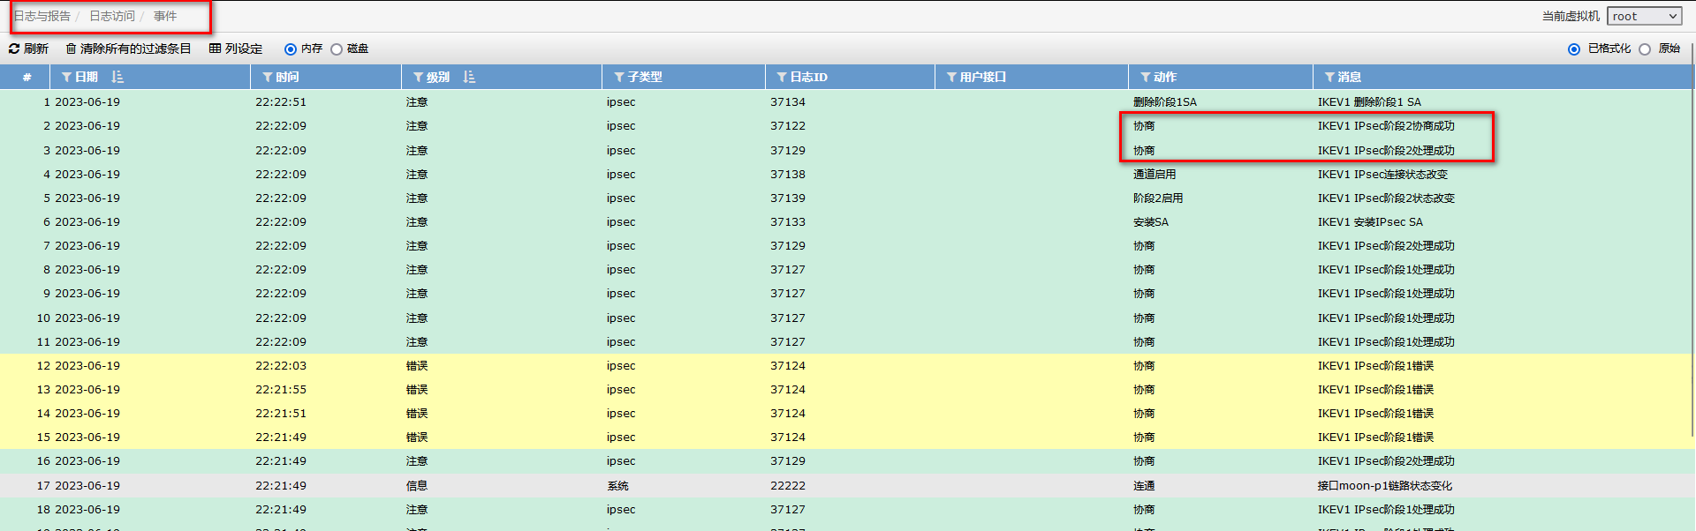

第二部分：
配置OPENSWAN

实验环境：CENTOS
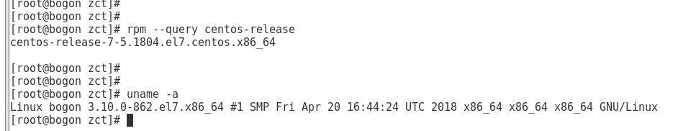

安装openswan
yum install -y openswan
查看openswan安装的配置文件，libreswan即openswan。
# rpm -qc libreswan
/etc/ipsec.conf
/etc/ipsec.d/policies/block
/etc/ipsec.d/policies/clear
/etc/ipsec.d/policies/clear-or-private
/etc/ipsec.d/policies/portexcludes.conf
/etc/ipsec.d/policies/private
/etc/ipsec.d/policies/private-or-clear
/etc/ipsec.secrets
/etc/pam.d/pluto

开启ipv4转发，关闭ICMP重定向
cat >> /etc/sysctl.conf << EOF
echo net.ipv4.ip_forward = 1
EOF

sysctl -a | egrep "ipv4.*(accept|send)_redirects" | awk -F "=" '{print$1"= 0"}'
sysctl -a | egrep "ipv4.*(accept|send)_redirects" | awk -F "=" '{print$1"= 0"}' >> /etc/sysctl.conf
sysctl -p /etc/sysctl.conf
关闭SELINUX
临时关闭：setenforce 0

永久关闭：
#vi /etc/selinux/config
SELINUX=disabled
关闭防火墙或者开启IPSEC所需的端口UDP 500，UDP4500，ESP
这里关闭防火墙
systemctl stop firewalld
systemctl disable firewalld
配置openswan
在/etc/ipsec.conf中默认包含如下配置，建议将IPsec连接作为单独的文件添加到/etc/ipsec.d/
include /etc/ipsec.d/*.conf
在/etc/ipsec.secrets中默认包含如下配置，建议将IPsec共享密钥作为单独的文件添加到/etc/ipsec.d/
include /etc/ipsec.d/*.secrets
配置IPSEC预共享密钥

vim /etc/ipsec.d/ipsec.secrets
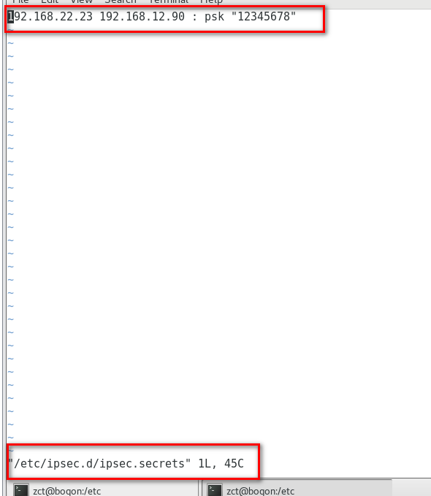
格式：本地用于连接的IP+空格+远端网关IP+空格+英文冒号+空格+PSK+预共享密钥，冒号的两边都有空格，密钥用英文双引号。
配置IPSEC连接
vim /etc/ipsec.d/ipsec.conf
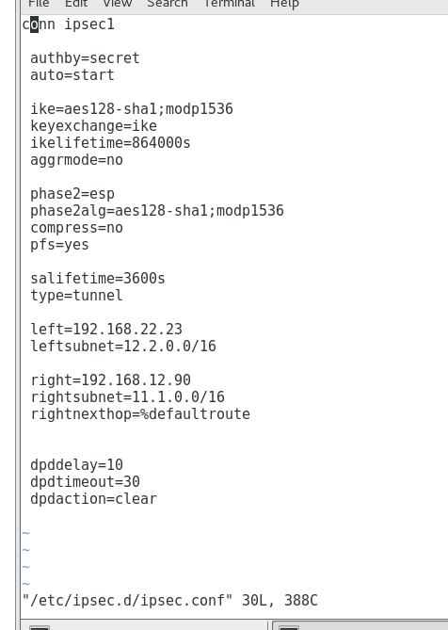

具体含义参考一下：
#ipsec连接名称
conn ipsec1

#phase1
#共享密钥
authby=secret
#start表示ipsec服务启动后会主动发起IPSEC连接;add只表示添加，服务启动不会发起连接,使用ipsec auto --up ipsec名称发起连接
auto=start
#阶段1密钥集
ike=aes128-sha1;modp1536
#ike密钥交换方式
keyexchange=ike
#阶段1生命周期
ikelifetime=86400s
#默认为no主模式，野蛮模式为yes
aggrmode=no

#phase2
#段2传输格式
phase2=esp
#阶段2密钥集
phase2alg=aes128-sha1;modp1536
#关闭压缩
compress=no
#开启PFS
pfs=yes
#阶段2生命周期
salifetime=3600s
#隧道模式
type=tunnel
#本地IP
left=192.168.22.23
#本地子网
leftsubnet=11.1.0.0/16
#远端VPN网关IP
right=100.1.1.2
#远端子网
rightsubnet=192.168.0.0/24
#远端路由按缺省配置
rightnexthop=%defaultroute
#开启dpd检查，每10s发起一次dpd检查，30s没有收到dpd响应，则清楚该ipsec连接
dpddelay=10
dpdtimeout=30
dpdaction=clear
启动IPSEC服务
systemctl start ipsec
systemctl enable ipsec
通过ipsec verify进行配置项校验。如果回显信息全部为OK时，表示配置成功。
# ipsec verify
Verifying installed system and configuration files
Version check and ipsec on-path [OK]
Libreswan 3.25 (netkey) on 3.10.0-1160.49.1.el7.x86_64
Checking for IPsec support in kernel [OK]
NETKEY: Testing XFRM related proc values
ICMP default/send_redirects [OK]
ICMP default/accept_redirects [OK]
XFRM larval drop [OK]
Pluto ipsec.conf syntax [OK]
Two or more interfaces found, checking IP forwarding [OK]
Checking rp_filter [OK]
Checking that pluto is running [OK]
Pluto listening for IKE on udp 500 [OK]
Pluto listening for IKE/NAT-T on udp 4500 [OK]
Pluto ipsec.secret syntax [OK]
Checking 'ip' command [OK]
Checking 'iptables' command [OK]
Checking 'prelink' command does not interfere with FIPS [OK]
Checking for obsolete ipsec.conf options [OK]

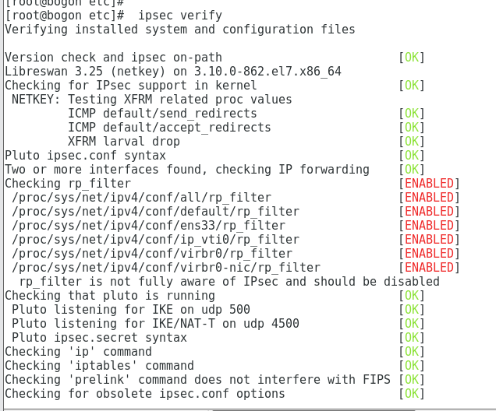

如遇到上述报错：
一下命令修改：
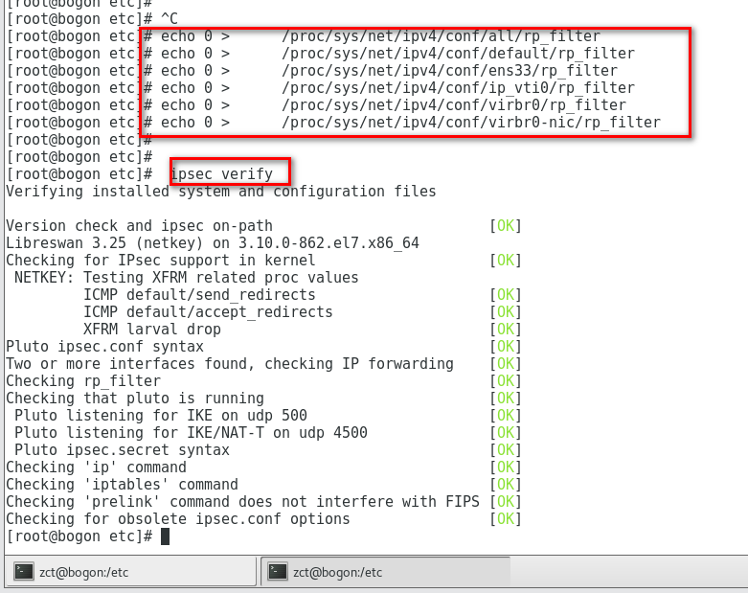

查看状态：
[root@bogon etc]# ipsec status
000 using kernel interface: netkey
000 interface lo/lo ::1@500
000 interface lo/lo 127.0.0.1@4500
000 interface lo/lo 127.0.0.1@500
000 interface ens33/ens33 192.168.22.23@4500
000 interface ens33/ens33 192.168.22.23@500
000 interface virbr0/virbr0 192.168.122.1@4500
000 interface virbr0/virbr0 192.168.122.1@500
000
000
000 fips mode=disabled;
000 SElinux=enabled
000 seccomp=disabled
000
000 config setup options:
000
000 configdir=/etc, configfile=/etc/ipsec.conf, secrets=/etc/ipsec.secrets, ipsecdir=/etc/ipsec.d
000 nssdir=/etc/ipsec.d, dumpdir=/run/pluto, statsbin=unset
000 dnssec-rootkey-file=/var/lib/unbound/root.key, dnssec-trusted=<unset>
000 sbindir=/usr/sbin, libexecdir=/usr/libexec/ipsec
000 pluto_version=3.25, pluto_vendorid=OE-Libreswan-3.25
000 nhelpers=-1, uniqueids=yes, dnssec-enable=yes, perpeerlog=no, logappend=yes, logip=yes, shuntlifetime=900s, xfrmlifetime=300s
000 ddos-cookies-threshold=50000, ddos-max-halfopen=25000, ddos-mode=auto
000 ikeport=500, ikebuf=0, msg_errqueue=yes, strictcrlpolicy=no, crlcheckinterval=0, listen=<any>, nflog-all=0
000 ocsp-enable=no, ocsp-strict=no, ocsp-timeout=2, ocsp-uri=<unset>
000 ocsp-trust-name=<unset>
000 ocsp-cache-size=1000, ocsp-cache-min-age=3600, ocsp-cache-max-age=86400, ocsp-method=get
000 secctx-attr-type=32001
000 debug:
000
000 nat-traversal=yes, keep-alive=20, nat-ikeport=4500
000 virtual-private (%priv):
000 - allowed subnets: 10.0.0.0/8, 192.168.0.0/16, 172.16.0.0/12, 25.0.0.0/8, 100.64.0.0/10, fd00::/8, fe80::/10
000
000 ESP algorithms supported:
000
000 algorithm ESP encrypt: id=3, name=ESP_3DES, ivlen=8, keysizemin=192, keysizemax=192
000 algorithm ESP encrypt: id=6, name=ESP_CAST, ivlen=8, keysizemin=128, keysizemax=128
000 algorithm ESP encrypt: id=11, name=ESP_NULL, ivlen=0, keysizemin=0, keysizemax=0
000 algorithm ESP encrypt: id=12, name=ESP_AES, ivlen=8, keysizemin=128, keysizemax=256
000 algorithm ESP encrypt: id=13, name=ESP_AES_CTR, ivlen=8, keysizemin=128, keysizemax=256
000 algorithm ESP encrypt: id=14, name=ESP_AES_CCM_A, ivlen=8, keysizemin=128, keysizemax=256
000 algorithm ESP encrypt: id=15, name=ESP_AES_CCM_B, ivlen=8, keysizemin=128, keysizemax=256
000 algorithm ESP encrypt: id=16, name=ESP_AES_CCM_C, ivlen=8, keysizemin=128, keysizemax=256
000 algorithm ESP encrypt: id=18, name=ESP_AES_GCM_A, ivlen=8, keysizemin=128, keysizemax=256
000 algorithm ESP encrypt: id=19, name=ESP_AES_GCM_B, ivlen=8, keysizemin=128, keysizemax=256
000 algorithm ESP encrypt: id=20, name=ESP_AES_GCM_C, ivlen=8, keysizemin=128, keysizemax=256
000 algorithm ESP encrypt: id=22, name=ESP_CAMELLIA, ivlen=8, keysizemin=128, keysizemax=256
000 algorithm ESP encrypt: id=23, name=ESP_NULL_AUTH_AES_GMAC, ivlen=8, keysizemin=128, keysizemax=256
000 algorithm ESP encrypt: id=252, name=ESP_SERPENT, ivlen=8, keysizemin=128, keysizemax=256
000 algorithm ESP encrypt: id=253, name=ESP_TWOFISH, ivlen=8, keysizemin=128, keysizemax=256
000 algorithm AH/ESP auth: id=1, name=AUTH_ALGORITHM_HMAC_MD5, keysizemin=128, keysizemax=128
000 algorithm AH/ESP auth: id=2, name=AUTH_ALGORITHM_HMAC_SHA1, keysizemin=160, keysizemax=160
000 algorithm AH/ESP auth: id=5, name=AUTH_ALGORITHM_HMAC_SHA2_256, keysizemin=256, keysizemax=256
000 algorithm AH/ESP auth: id=6, name=AUTH_ALGORITHM_HMAC_SHA2_384, keysizemin=384, keysizemax=384
000 algorithm AH/ESP auth: id=7, name=AUTH_ALGORITHM_HMAC_SHA2_512, keysizemin=512, keysizemax=512
000 algorithm AH/ESP auth: id=8, name=AUTH_ALGORITHM_HMAC_RIPEMD, keysizemin=160, keysizemax=160
000 algorithm AH/ESP auth: id=9, name=AUTH_ALGORITHM_AES_XCBC, keysizemin=128, keysizemax=128
000 algorithm AH/ESP auth: id=250, name=AUTH_ALGORITHM_AES_CMAC_96, keysizemin=128, keysizemax=128
000 algorithm AH/ESP auth: id=251, name=AUTH_ALGORITHM_NULL_KAME, keysizemin=0, keysizemax=0
000
000 IKE algorithms supported:
000
000 algorithm IKE encrypt: v1id=5, v1name=OAKLEY_3DES_CBC, v2id=3, v2name=3DES, blocksize=8, keydeflen=192
000 algorithm IKE encrypt: v1id=8, v1name=OAKLEY_CAMELLIA_CBC, v2id=23, v2name=CAMELLIA_CBC, blocksize=16, keydeflen=128
000 algorithm IKE encrypt: v1id=-1, v1name=n/a, v2id=20, v2name=AES_GCM_C, blocksize=16, keydeflen=128
000 algorithm IKE encrypt: v1id=-1, v1name=n/a, v2id=19, v2name=AES_GCM_B, blocksize=16, keydeflen=128
000 algorithm IKE encrypt: v1id=-1, v1name=n/a, v2id=18, v2name=AES_GCM_A, blocksize=16, keydeflen=128
000 algorithm IKE encrypt: v1id=13, v1name=OAKLEY_AES_CTR, v2id=13, v2name=AES_CTR, blocksize=16, keydeflen=128
000 algorithm IKE encrypt: v1id=7, v1name=OAKLEY_AES_CBC, v2id=12, v2name=AES_CBC, blocksize=16, keydeflen=128
000 algorithm IKE encrypt: v1id=65004, v1name=OAKLEY_SERPENT_CBC, v2id=65004, v2name=SERPENT_CBC, blocksize=16, keydeflen=128
000 algorithm IKE encrypt: v1id=65005, v1name=OAKLEY_TWOFISH_CBC, v2id=65005, v2name=TWOFISH_CBC, blocksize=16, keydeflen=128
000 algorithm IKE encrypt: v1id=65289, v1name=OAKLEY_TWOFISH_CBC_SSH, v2id=65289, v2name=TWOFISH_CBC_SSH, blocksize=16, keydeflen=128
000 algorithm IKE PRF: name=HMAC_MD5, hashlen=16
000 algorithm IKE PRF: name=HMAC_SHA1, hashlen=20
000 algorithm IKE PRF: name=HMAC_SHA2_256, hashlen=32
000 algorithm IKE PRF: name=HMAC_SHA2_384, hashlen=48
000 algorithm IKE PRF: name=HMAC_SHA2_512, hashlen=64
000 algorithm IKE PRF: name=AES_XCBC, hashlen=16
000 algorithm IKE DH Key Exchange: name=MODP1024, bits=1024
000 algorithm IKE DH Key Exchange: name=MODP1536, bits=1536
000 algorithm IKE DH Key Exchange: name=MODP2048, bits=2048
000 algorithm IKE DH Key Exchange: name=MODP3072, bits=3072
000 algorithm IKE DH Key Exchange: name=MODP4096, bits=4096
000 algorithm IKE DH Key Exchange: name=MODP6144, bits=6144
000 algorithm IKE DH Key Exchange: name=MODP8192, bits=8192
000 algorithm IKE DH Key Exchange: name=DH19, bits=512
000 algorithm IKE DH Key Exchange: name=DH20, bits=768
000 algorithm IKE DH Key Exchange: name=DH21, bits=1056
000 algorithm IKE DH Key Exchange: name=DH22, bits=1024
000 algorithm IKE DH Key Exchange: name=DH23, bits=2048
000 algorithm IKE DH Key Exchange: name=DH24, bits=2048
000
000 stats db_ops: {curr_cnt, total_cnt, maxsz} :context={0,6,64} trans={0,6,6936} attrs={0,6,4624}
000
000 Connection list:
000
000 "ipsec1": 12.2.0.0/16===192.168.22.23<192.168.22.23>...192.168.12.90<192.168.12.90>===11.1.0.0/16; erouted; eroute owner: #18
000 "ipsec1": oriented; my_ip=unset; their_ip=unset; my_updown=ipsec _updown;
000 "ipsec1": xauth us:none, xauth them:none, my_username=[any]; their_username=[any]
000 "ipsec1": our auth:secret, their auth:secret
000 "ipsec1": modecfg info: us:none, them:none, modecfg policy:push, dns:unset, domains:unset, banner:unset, cat:unset;
000 "ipsec1": labeled_ipsec:no;
000 "ipsec1": policy_label:unset;
000 "ipsec1": ike_life: 86400s; ipsec_life: 3600s; replay_window: 32; rekey_margin: 540s; rekey_fuzz: 100%; keyingtries: 0;
000 "ipsec1": retransmit-interval: 500ms; retransmit-timeout: 60s;
000 "ipsec1": initial-contact:no; cisco-unity:no; fake-strongswan:no; send-vendorid:no; send-no-esp-tfc:no;
000 "ipsec1": policy: PSK+ENCRYPT+TUNNEL+PFS+UP+IKEV1_ALLOW+IKEV2_ALLOW+SAREF_TRACK+IKE_FRAG_ALLOW+ESN_NO;
000 "ipsec1": conn_prio: 16,16; interface: ens33; metric: 0; mtu: unset; sa_prio:auto; sa_tfc:none;
000 "ipsec1": nflog-group: unset; mark: unset; vti-iface:unset; vti-routing:no; vti-shared:no; nic-offload:auto;
000 "ipsec1": our idtype: ID_IPV4_ADDR; our id=192.168.22.23; their idtype: ID_IPV4_ADDR; their id=192.168.12.90
000 "ipsec1": dpd: action:clear; delay:10; timeout:30; nat-t: encaps:auto; nat_keepalive:yes; ikev1_natt:both
000 "ipsec1": newest ISAKMP SA: #17; newest IPsec SA: #18;
000 "ipsec1": IKE algorithms: AES_CBC_128-HMAC_SHA1-MODP1536
000 "ipsec1": IKE algorithm newest: AES_CBC_128-HMAC_SHA1-MODP1536
000 "ipsec1": ESP algorithms: AES_CBC_128-HMAC_SHA1_96-MODP1536
000 "ipsec1": ESP algorithm newest: AES_CBC_128-HMAC_SHA1_96; pfsgroup=MODP1536
000
000 Total IPsec connections: loaded 1, active 1
000
000 State Information: DDoS cookies not required, Accepting new IKE connections
000 IKE SAs: total(1), half-open(0), open(0), authenticated(1), anonymous(0)
000 IPsec SAs: total(2), authenticated(2), anonymous(0)
000
000 #10: "ipsec1":500 STATE_QUICK_I2 (sent QI2, IPsec SA established); EVENT_SA_REPLACE in 464s; isakmp#9; idle; import:admin initiate
000 #10: "ipsec1" esp.d736092d@192.168.12.90 esp.7adf6cb6@192.168.22.23 tun.0@192.168.12.90 tun.0@192.168.22.23 ref=0 refhim=0 Traffic: ESPin=0B ESPout=0B! ESPmax=4194303B
000 #17: "ipsec1":500 STATE_MAIN_I4 (ISAKMP SA established); EVENT_SA_REPLACE in 84869s; newest ISAKMP; lastdpd=1s(seq in:0 out:0); idle; import:admin initiate
000 #18: "ipsec1":500 STATE_QUICK_I2 (sent QI2, IPsec SA established); EVENT_SA_REPLACE in 2060s; newest IPSEC; eroute owner; isakmp#17; idle; import:admin initiate
000 #18: "ipsec1" esp.d7360930@192.168.12.90 esp.bec131a3@192.168.22.23 tun.0@192.168.12.90 tun.0@192.168.22.23 ref=0 refhim=0 Traffic: ESPin=0B ESPout=0B! ESPmax=4194303B
000
000 Bare Shunt list:
000
[root@bogon etc]#

业务测试：
从11.1.1.2 ping 12.2.1.1 可ping通
从中间设备抓ESP报文：
