# 拓扑

防火墙的上联接口port3接虚拟交换机，下联接口port4接虚拟交换机

如下图所示：

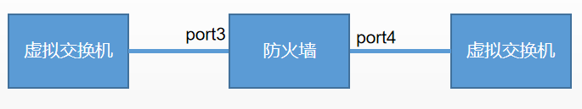

# 路由器端配置

#

interface XGigabitEthernet0/0/1

undo portswitch

description FJ_FZ_SHIJU-NE40-1

ip binding vpn-instance fw

ip address 10.131.121.86 255.255.255.252

ospf network-type p2p

#

ospf 1 router-id 10.131.120.84

import-route direct

area 0.0.0.0

network 10.131.9.10 0.0.0.0

network 10.131.120.84 0.0.0.0

network 10.131.122.130 0.0.0.0

#

# 3、防火墙端配置

## 配置area

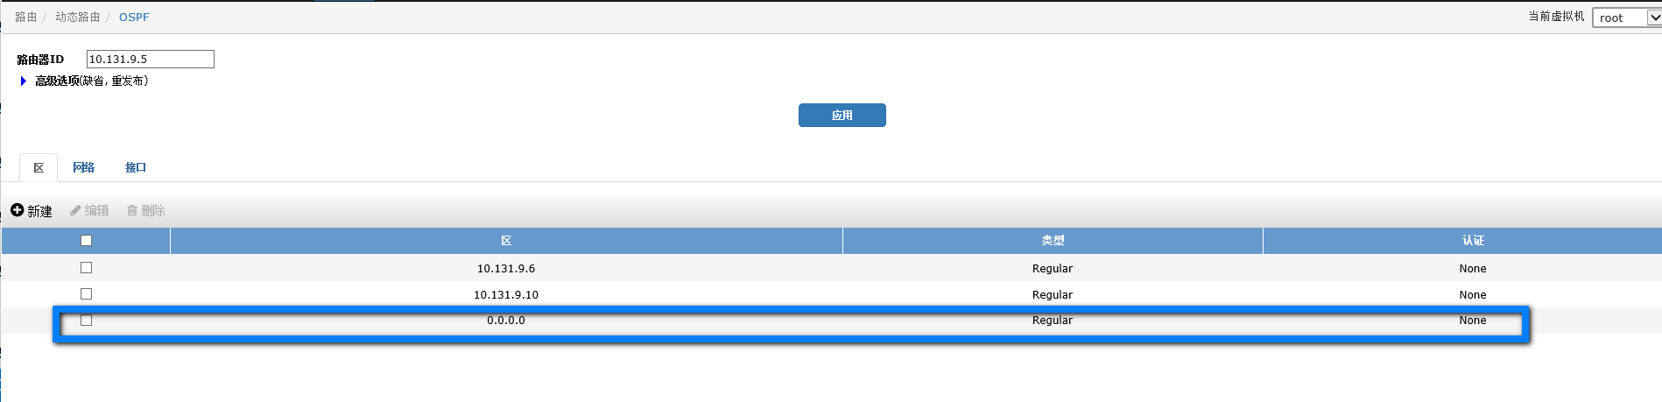

## 配置network

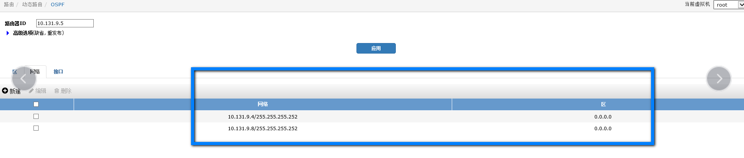

## **配置接口**

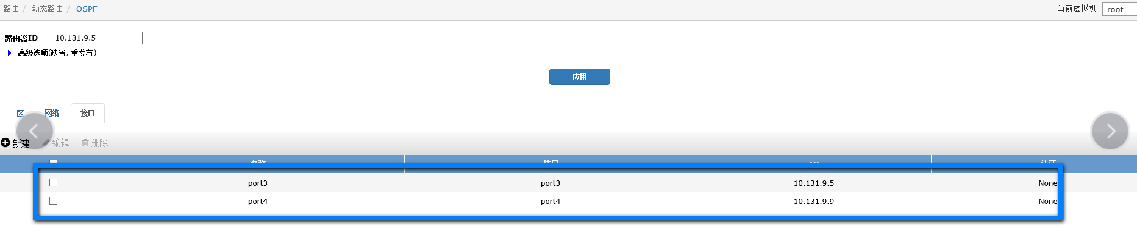

命令行下配置，point-to-point模式需要在命令行下设置。

define router ospf

define area

edit 0.0.0.0

next

end

define network

edit 1

set prefix 10.131.9.4 255.255.255.252

next

edit 2

set prefix 10.131.9.8 255.255.255.252

next

end

define ospf-interface

edit "port3"

set cost 10

set interface "port3"

set ip 10.131.9.5

set network-type point-to-point

next

edit "port4"

set cost 10

set interface "port4"

set ip 10.131.9.9

set network-type point-to-point

next

end

set router-id 10.131.9.5

End

# **4、配置完毕**

可以看到学到的ospf路由

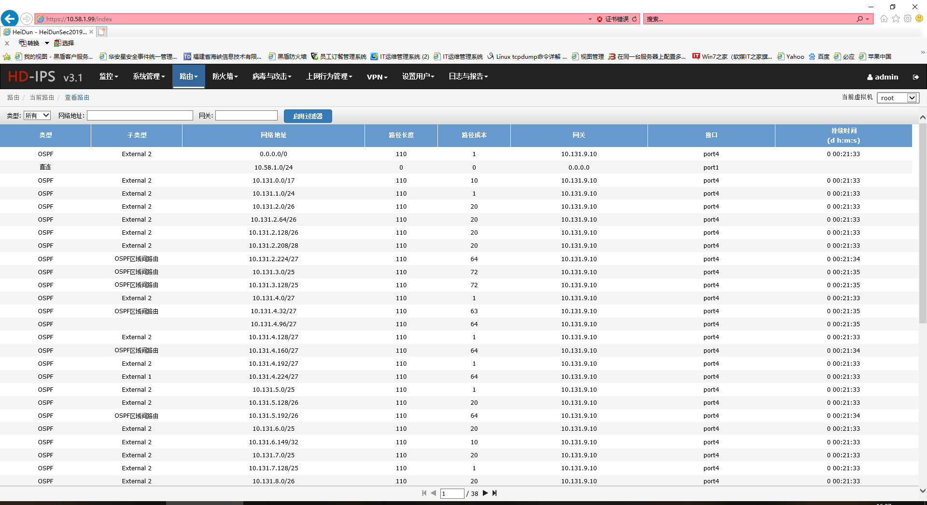

# 配置文件

