根据茂名石化项目情况，用华为S6720交换机，将一个40G口分成4个10G口，配置如下：

1，  进入40G接口

system-view

interface 40GE0/0/1

2，拆分接口

port split split-type 40GE:4\*XGE

确认，然后重启交换机

3，  查看拆分接口

dis port split

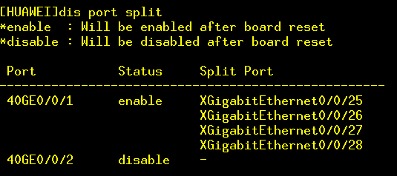

XG0/0/25 到 0/0/28 是拆分后的接口

4，做链路聚合

interface Eth-Trunk1

trunkport XGigabitEthernet 0/0/25 to 0/0/28

port link-type trunk

port trunk allow-pass vlan 2 to 4094

interface Vlanif2

ip address 10.1.1.2 255.255.255.0

5，  在防火墙上配置链路聚合

define system interface

    edit "lacp"

        set vdom "root"

        set type aggregate

            set member "m1/1" "m1/2" "m1/3" "m1/4"

        set lacp-mode static

    next

    edit "vlan2"

        set vdom "root"

        set ip 10.1.1.1 255.255.255.0

        set allowaccess ping telnet

        set interface "lacp"

        set vlanid 2

    next

end

交换机可以ping通防火墙vlan2接口IP

